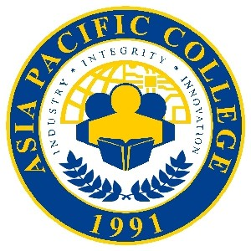

**APC Week T-Shirt Design Contest**

**#WeAreRams #RAMPRIDE #ProudtobeRAM**

**Mechanics:**

1. The contest is open to all APC students, staff, and faculty.
2. Design a t-shirt that will look good on all the school colors:

Red – School of Multimedia Arts

Yellow – School of Management

Blue – School of Computing and Information Technology

Orange – School of Engineering

Baby Blue – Senior High School

White – Graduate School

1. Like the official Facebook page of Asia Pacific College: <https://www.facebook.com/asiapacificcollege.edu/>
2. Submit entries by posting your photo (make sure to change your settings to Public) on your Facebook account and tag **Asia Pacific College**.
3. The design with the most number of Likes (reactionsincluded) will win five (5) SM Movie tickets with equivalent to PHP1,000!   
   Two (2) runner-ups will get two (2) SM Movie tickets each.
4. Deadline of entries is on January 31, 2018, 5:00 P.M.
5. Winners will be announced via APC FB on February 1, 2018.